INGLESE TESTO 2
1. Pie chart reading

This is a pie chart about energy sources in the U.K. in 2005. Examine it.

- What percentage of fossil fuels did the U. K. consume that year ?
…………………………………………………………………………………
- Do you find that renewable sources played an important role in the country? Why?
…………………………………………………………………………………
- Comparing the British situation to what you know about Italy, what was
peculiar to the U.K.?
………………………………………………………………………………….
………………………………………………………………………………….
- Does the pie chart give us enough information about the production of renewable and non-renewable energy sources ? Why?
……………………………………………………………………………………
……………………………………………………………………………………
- Explain in about three lines what the pie chart shows.
……………………………………………………………………………………
……………………………………………………………………………………
……………………………………………………………………………………

Dep. of Trade and Industry of the U.K.,
Digest of United Kingdom Energy Statistics
2. Now take into consideration the following graph.

1. When did the electricity production from nuclear energy reach its peak ?
a. in 1985 b. in 1998 c. in 2000 d. there are no peaks

2. How did the production of electricity change between 2000 and 2005 ?
……………………………………………………………………………………………
……………………………………………………………………………………………
3. What additional information does the definition of “conventional thermal” provide ?
……………………………………………………………………………………………
……………………………………………………………………………………………

Electricity production in the UK

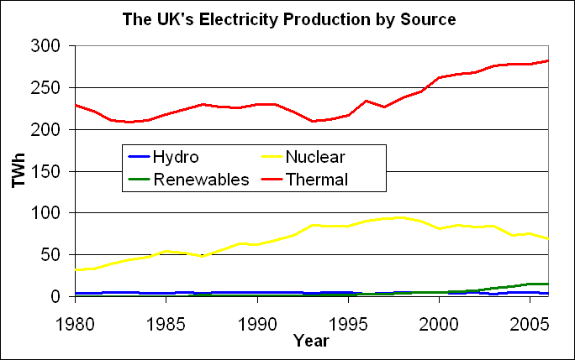

From Wikipedia

Conventional Thermal
(…) conventional thermal plants provide the bulk of the electricity supply in the UK. According to DTI, conventional thermal generation in 2004 consisted of natural gas (53 percent), coal (44 percent), oil (2 percent), and other (1 percent).

Source: EIA

3. Read the following statements.

Country Analysis

- With its significant North Sea reserves, the United Kingdom is a major European oil and natural gas producer.
- The UK is the largest oil producer in the EU, but production has declined since peaking in 1999.
- The UK is one of the largest natural gas producers in the world.
- Most UK coal consumption is for power generation.
- Natural gas-fired power stations are replacing coal as the principle source of the UK power supply.
Source : EIA International Energy Annual

NOW COMPLETE

1) In this context POWER is the synonym for:

a) influence b) electricity c) energy

2) What type of reserves has the U.K. got?
…………………………………………………………………………………………..
3) What type of fuel production is the U.K. the leader in?
…………………………………………………………………………………………..
4) Was the production of oil stable between 1999 and 2005?
…………………………………………………………………………………………..
5) Which statement/s let/s us understand why the U.K. had no need of developing renewable energy production until 2005? Highlight it/them in blue.

6) Find the statement that gives one of the reasons why the U.K. has recently changed its energy policy. Highlight it in green.

7) Underline all the words/expressions belonging to the energy domain. Look up in a bilingual and a monolingual dictionary and complete the chart:

word/expression | grammatical category (noun, adjective,verbs…) | pronunciation | definition (in English) | examples of use | Italian equivalent

8) Which dictionary has been useful to give definitions? …………………………………………. 9) Which one for the grammatical categories ? ………………….…………………….

4. Look at the tables of consumption of R.E.S. in EU nations and the targets they have to reach by 2020 (Annex I of the Directive of the European Parliament and of the Council of the Promotion of the use of energy from renewable sources).

R.E.S: renewable energy sources

EU NATIONS | Share of energy from RES in 2005 | Target for share of energy from RES in 2020
Belgium | 2,2% | 13,0%
Bulgaria | 9,4% | 16,0%
Czech Republic | 6,1% | 13,0%
Denmark | 17,0% | 30,0%
Germany | 5,8% | 18,0%
Estonia | 18,0% | 25,0%
Ireland | 3,1% | 16,0%
Greece | 6,9% | 18,0%
Spain | 8,7% | 20,0%
France | 10,3% | 23,0%
Italy | 5,2% | 17,0%
Cyprus | 2,9% | 13,0%
Latvia | 32,6% | 40,0%
Lithuania | 15,0% | 23,0%
Luxembourg | 0,9% | 11,0%
Hungary | 4,3% | 13,0%
Malta | 0,0% | 10,0%
The Netherlands | 2,4% | 14,0%
Austria | 23,3% | 34,0%
Poland | 7,2% | 15,0%
Portugal | 20,5% | 31,0%
Romania | 17,8% | 24,0%
Slovenia | 16,0% | 25,0%
Slovak Republic | 6,7% | 14,0%
Finland | 28,5% | 38,0%
Sweden | 39,8% | 49,0%
United Kingdom | 1,7% | 15,0%
Turkey | 13,6% | 25,0%
Iceland | 73,0% | 80,0%
Norway | 40,4% | 50,0%

1. Compare data referring to Italy and the U.K. Which country used more R.E.S. in the past ?
……………………………………………………………………………………….

2. How would you define the British situation at the time?
……………………………………………………………………………………….

3. What E.U. countries used more R.E.S.? Could you explain why ?
……………………………………………………………………………………….

- Calculate the percentage of R.E.S. the countries have to cover to meet the established targets. Then create a BAR GRAPH showing:
- their production in 2005;
- their target for 2020;
- the percentage of consumption they have to cover.

5. Read the text.

…........................................................................................

The use of renewable energy is not new. More than 150 years ago, wood, which is one form of biomass, supplied up to 90% of our energy needs. As the use of coal, petroleum, and natural gas expanded, the United States became less reliant on wood as an energy source. Today, we are looking again at renewable sources to find new ways to use them to help meet our energy needs.
In 2008, consumption of renewable sources in the United States totalled 7.3 quadrillion Btu — 1 quadrillion is the number 1 followed by 15 zeros — or about 7% of all energy used nationally.

The Role of Renewable Energy Consumption in the Nation's Energy Supply, 2008

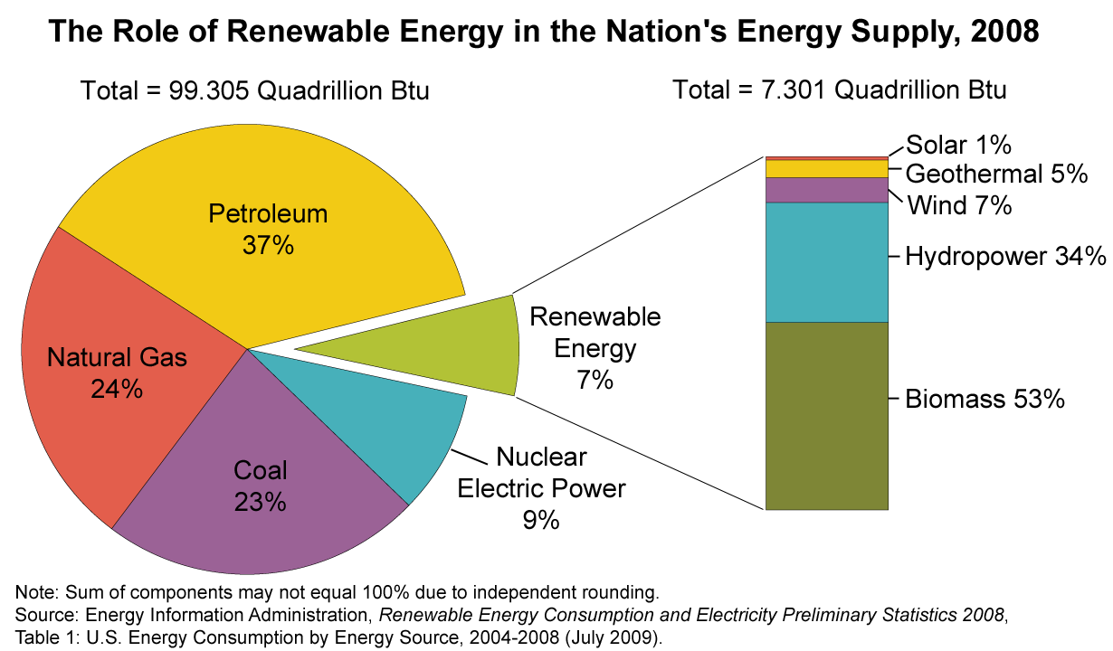

Btu: British thermal unit

Over half of renewable energy goes to producing electricity. About 9% of U.S. electricity was generated from renewable sources in 2008. The next largest use of renewable energy is the production of heat and steam for industrial purposes. Renewable fuels, such as ethanol, are also used for transportation and to provide heat for homes and businesses.
Renewable energy plays an important role in the supply of energy. When renewable energy sources are used, the demand for fossil fuels is reduced. Unlike fossil fuels, non-biomass renewable sources of energy (hydropower, geothermal, wind, and solar) do not directly emit greenhouse gases.

1. GIVE A TITLE TO THE TEXT

2. FIND IN THE DOCUMENT

a. Taking into consideration only renewable resources, what was the position of wind in 2008?
…………………………………………………………………………………………………………
b. How much biomass was consumed in Btu ?
………………………………………………………………………………………………………..
c. Why was the biomass first among renewable resources? Find a reference in the text.
…………………………………………………………………………………………………………
d. How much energy from renewable resources was used in the U.S.A. in 2008 ?
…………………………………………………………………………………………………………
e. What was energy from renewable resources used for ?
…………………………………………………………………………………………………………
f. Why is the use of renewable energy important ?
…………………………………………………………………………………………………………

WRITING

Now exploiting the data offered by the texts you have read, write a short report on Energy resources in the U.K.
- Start by choosing the most important points of the “Country analysis”
- Use information from the pie chart and the graph and add statements so that you will have a complete picture of the production of energy and electricity
- Focus on the role of renewable resources
- Compare data/ add you remarks

Use and, in addition, besides, moreover at the beginning of the sentences to add information.
Use but, in contrast and on the contrary to express contrast.
Use because or as a consequence to express the cause and the consequence.

